



MONTHLY REPORT

**November 2024**

Submitted to

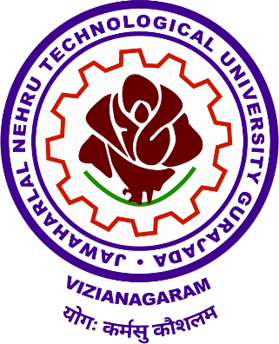

JNTU-GV University



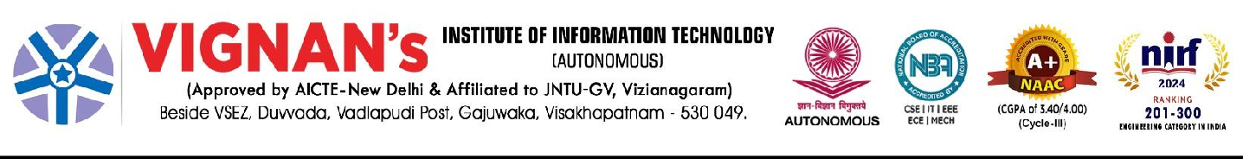

**JNTU-GV Monthly Report Index**

|  |  |  |
| --- | --- | --- |
| **S.NO** | **SUBJECT** | No. of events |
| **1.** | Important Conferences /Seminars and meetings Organized |  |
| National | **03** |
| International | **--** |
| **3.** | Activities related to Governance | 03 |
| **4.** | Training & Workshops organized | 02 |
| **5.** | Co-Curricular Activities | 10 |
| **6.** | NCC/NSS/Service Programs | -- |
| **7.** | Research Activities | 03 |
| Research Projects | **--** |
| Research Publications | -- |
| **8.** | Student Support Practices | 05 |
| **9.** | Extension & Community oriented Activities | **--** |
| **10.** | Creative & Innovative in curriculum, Teaching Learning practices, Student Evaluation, Student Progression etc., | 1 |
| **11.** | Awards & Recognitions |  |
| **12.** | Projects initiated or completed | **--** |
| **13.** | Convocation Pendency & Proposals | **--** |
| **14.** | Any other Remarks / Suggestions | **--** |

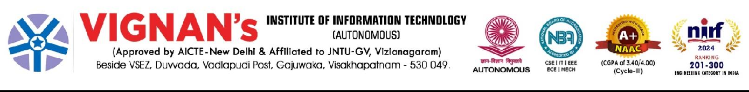

## INSTITUTE MONTHLY REPORT – NOVEMBER 2024

**Event Summary**

1. **Important Conferences /Seminars and meetings Organized**

|  |  |  |
| --- | --- | --- |
| S.No. | Date | Name of the event |
| 1 | 22.11.2024 | A Seminar on NEP-2020 & Its Practices through Curriculum |
| 2 | 26.11.2024 | A seminar on Importance of Coding and Campus Placements |
| 3 | 30.11.2024 | A Seminar on “Introduction to VLSI” |

1. **Organized Activities related to Governance**

|  |  |  |
| --- | --- | --- |
| S.No. | Date | Name of the event |
| 1 | 06.11.2024 | Team Rudra Success Meet by Chairman Sir Organised by Vignan's Institute of Information Technology(A). |
| 2 | 22.11.2024 | THE GOVERNING BODY MEETING, Organised by Vignan's Institute of Information Technology(A) |
| 3 | 30.11.2024 | A Parents Faculty interactive meeting by Organised by The department of Basic Sciences and Humanities, VIIT(A) |

1. **Training & Workshops organized**

|  |  |  |
| --- | --- | --- |
| S.No. | Date | Name of the event |
| 1 | 12.11.2024 | A Workshop on Cyber Security by Faculties of ACSE by Faculties of ACSE Organised by The department of Computer Science Engineering, VIIT(A |
| 2 | 23.11.2024 | A WORKSHOP ON MACHINE LEARNING & DEEP LEARNING  by Dr.Mooli Harish, Quality Engineering Analyst Infosys, Bengaluru |

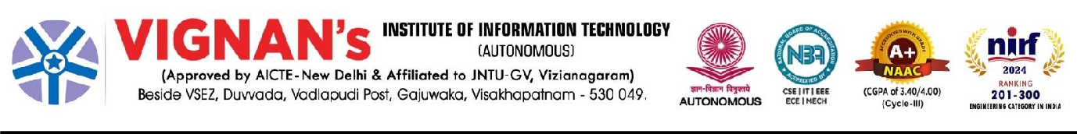

1. **Co-Curricular Activities:**

|  |  |  |
| --- | --- | --- |
| S.No. | Date | Name of the event |
| 1 | 02.11.2024 | A Industrial Visit by AMTZ Organised by The department of Electrical and Electronics Engineering, VIIT(A), |
| 2 | 06.11.2024 | Awareness Programme on Cyber Crime by Sri Shanka Brata Bagchi, IPS, Commissioner of Police, Visakhapatnam |
| 3 | 08.11.2024 | Industrial Visit to Défense Research and Development Organization (DRDO) and SITAR industry, Bangalore |
| 4 | 11.11.2024 | Awareness Program on Intellectual Property Rights & Patents by Mr.M.Srinivas, Eva IT and IP services |
| 5 | 13.11.2024 | An awareness Program on Entrepreneurship by Mr.V.Adiseshu, Joint Director,DIC Vizag |
| 6 | 15.11.2024 | Industrial Visit to AMTZ, Visakhapatnam by AMTZ Organised by The Department of Management Studies, VIIT(A). |
| 7 | 20.11.2024 | An awareness session on Integrating Science and spirituality at 21st century |
| 8 | 25.11.2024 | Industrial VISIT to RINL-Vizag Steel Plant |
| 9 | 26.11.2024 | Constitution Day of India - Poster Making Competition |
| 10 | 30.11.2024 | An Alumni Guest Lecture on Corporate Expectations |

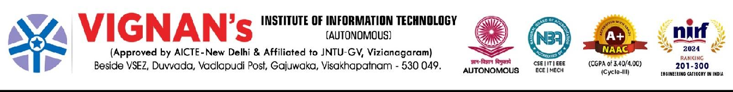

1. Research Activities

|  |  |  |
| --- | --- | --- |
| S.No. | Date | Name of the event |
| 1 | 20.11.2024 | FDP on “Potential Research Areas and Effective Research Paper Writing” |
| 2 | 21.11.2024 | A Workshop on Research Paper Writing |
| 3 | 30.11.2024 | A Seminar on Potential research areas and effective research paper writing |

1. Student Support Practices

|  |  |  |
| --- | --- | --- |
| S.No. | Date | Name of the event |
| 1 | 05.11.2024 | An awareness Program on Cancer Prevention for I-B.Tech Students by Dr. Anitha Raj, M.A., MBA, Ph.D Preventive Oncology from “The Indian Cancer Society”. |
| 2 | 06.11.2024 | The Status of broadcasting the Autobiography of the Eminent Personality - Broadcasted the Autobiography of Shri Ratan Tata |
| 3 | 14.11.2024 | YUVA -Vignan Students Performed a Skit at CMR Central - Visakhapatnam |
| 4 | 18.11.2024 | Awareness program on U.S VISA Application Process by U.S. Consulate General, Hyderabad |
| 5 | 19.11.2024 | Awareness program on U.S VISA Application Process by U.S. Consulate General, Hyderabad |

1. Creative & Innovative in curriculum. Teaching Learning practices,

|  |  |  |
| --- | --- | --- |
| S.No. | Date | Name of the event |
| 1 | 18.11.2024 | Add-On Course on BHAGAVAD GITA, in collaboration with ISKAN, Visakhapatnam by Organised by The Department of Civil Engineering, VIIT(A). |

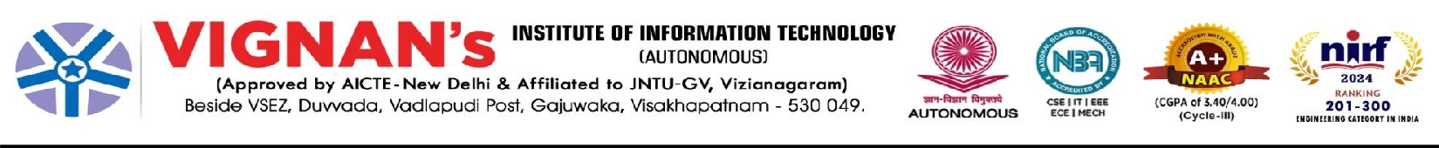

* 1. **Important Conferences /Seminars and meetings Organized**

|  |  |  |
| --- | --- | --- |
| S.No. | Date | Name of the event |
| 1 | 22.11.2024 | A Seminar on NEP-2020 & Its Practices through Curriculum |
| 2 | 26.11.2024 | A seminar on Importance of Coding and Campus Placements |
| 3 | 30.11.2024 | A Seminar on “Introduction to VLSI” |

|  |  |  |
| --- | --- | --- |
| S.No | Particulars | Image |
| 1 | **A Seminar on NEP-2020 & Its Practices through Curriculum**  by Prof.A.K.Bakhshi, Vice Chancellor, PDM University by Prof.A.K.Bakhshi Organised by Vignan's Institute of Information Technology(A),On 22.11.2024 | WhatsApp Image 2024-11-23 at 15.44.44.jpeg  WhatsApp Image 2024-11-23 at 15.44.24.jpeg WhatsApp Image 2024-11-23 at 15.18.29.jpeg WhatsApp Image 2024-11-23 at 15.44.23.jpeg |

## A seminar on Importance of Coding and Campus Placements

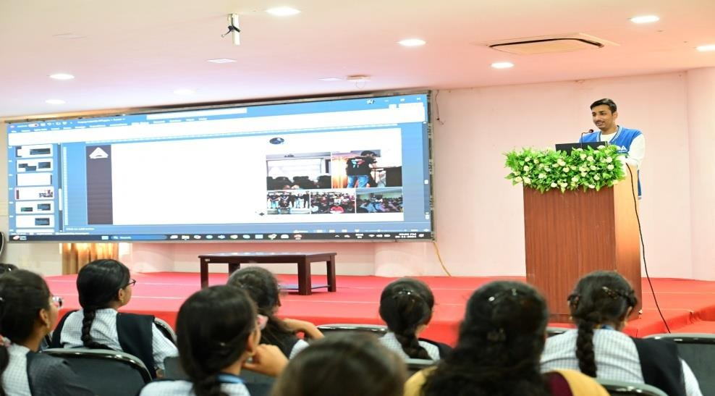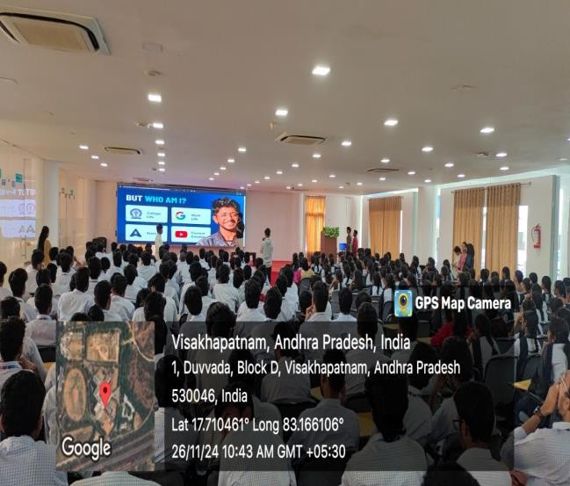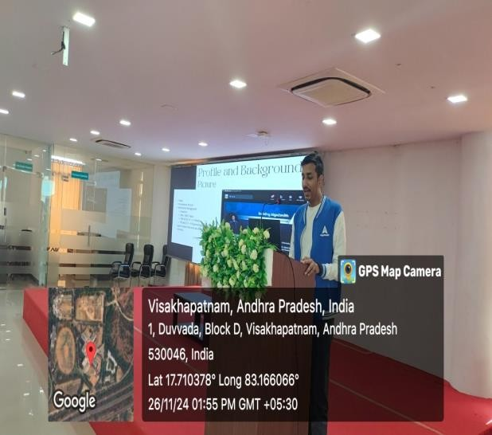

Organised for the students of CSE & ACSE students by Mr. Vivek Gupta, Co- founder Algozenih, ex- Google and Prayag Dwivedi-Community manger of Algozenith.

This event organised by The department of Computer Science Engineering, VIIT(A),On 26.11.2024

## A Seminar on

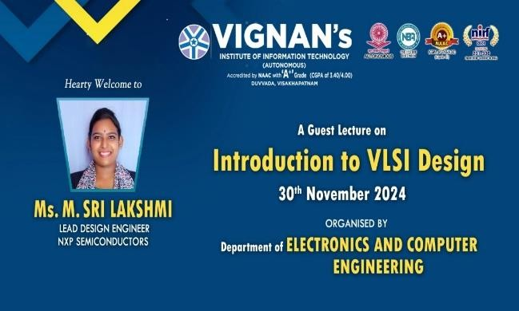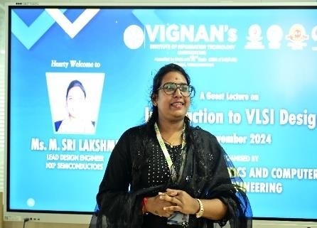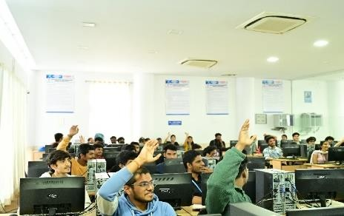

**“Introduction to VLSI”**

by Ms. M.Sri Lakshmi, Lead Design Engineer, NXP Semiconductors by Ms. M.Sri Lakshmi, Lead Design Engineer, NXP Semiconductors Organised by The department of Electronics and Computer Engineering, VIIT(A),On 30.11.2024

# Organized Activities related to Governance

|  |  |  |
| --- | --- | --- |
| S.No. | Date | Name of the event |
| 1 | 06.11.2024 | Team Rudra Success Meet by Chairman Sir Organised by Vignan's Institute of Information Technology(A). |
| 2 | 22.11.2024 | THE GOVERNING BODY MEETING, Organised by Vignan's Institute of Information Technology(A) |
| 3 | 30.11.2024 | A Parents Faculty interactive meeting by Organised by The department of Basic Sciences and Humanities, VIIT(A) |

1. **Organized Activities related to Governance**

|  |  |  |
| --- | --- | --- |
| **S.No** | **Particulars** | **Image** |
| 1. | **Team Rudra Success Meet by Chairman Sir Organised by Vignan's Institute of Information Technology(A),On 06.11.2024**  Event:  Honourable Chairman Sir awarded certificates to Rudra Cart team from Mechanical Department  WhatsApp Image 2024-11-07 at 11.35.08.jpeg | WhatsApp Image 2024-11-07 at 14.48.25 (1).jpeg WhatsApp Image 2024-11-07 at 14.48.25.jpeg  WhatsApp Image 2024-11-07 at 11.35.07.jpeg |

* 1. **THE GOVERNING BODY MEETING**

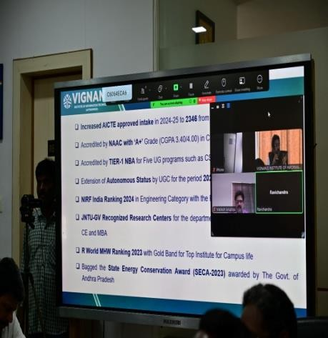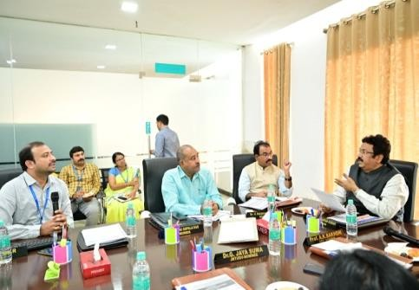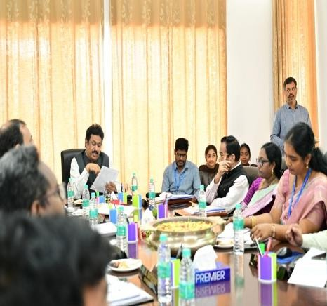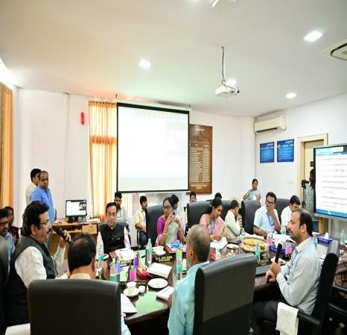

Organised by Vignan's Institute of Information Technology(A),On 22.11.2024

* 1. **A Parents Faculty interactive meeting**

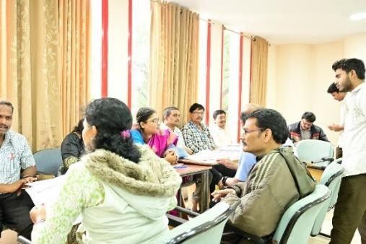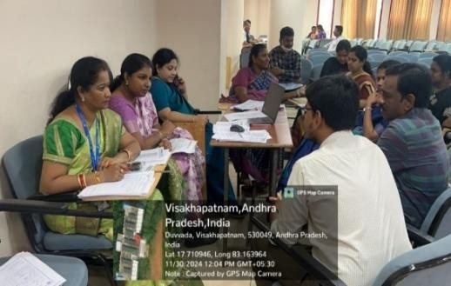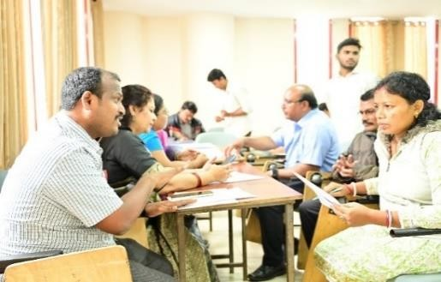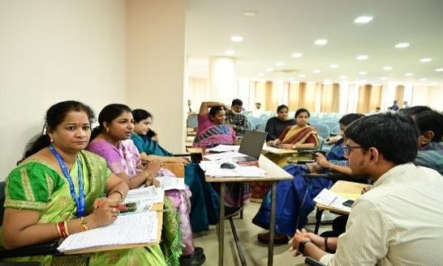

by Organised by The department of Basic Sciences and Humanities, VIIT(A),On 30.11.2024

# Training & Workshops organized

|  |  |  |
| --- | --- | --- |
| S.No. | Date | Name of the event |
| 1 | 12.11.2024 | A Workshop on Cyber Security by Faculties of ACSE by Faculties of ACSE Organised by The department of Computer Science Engineering, VIIT(A |
| 2 | 23.11.2024 | A WORKSHOP ON MACHINE LEARNING & DEEP LEARNING by Dr.Mooli Harish, Quality Engineering Analyst Infosys, Bengaluru |

1. **Training & Workshops organized**

|  |  |  |
| --- | --- | --- |
| S.No | Particulars | Image |
| 1. | **A Workshop on Cyber Security**  by Faculties of ACSE by Faculties of ACSE Organised by The department of Computer Science Engineering, VIIT(A),On 12.11.2024  Event:Cyber Security Workshop was conducted by “Cyber Threya “ on 11th & 12th November,2024 | WhatsApp Image 2024-11-13 at 15.27.00 (1).jpeg WhatsApp Image 2024-11-13 at 15.27.00.jpeg |
|  |  |  |

* 1. A WORKSHOP ON MACHINE LEARNING &

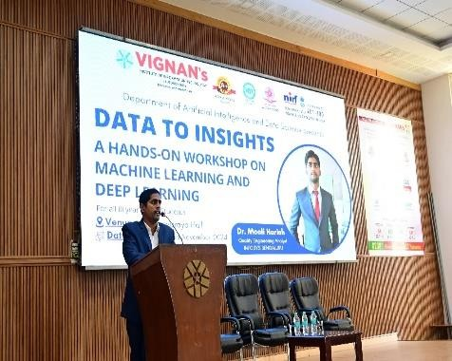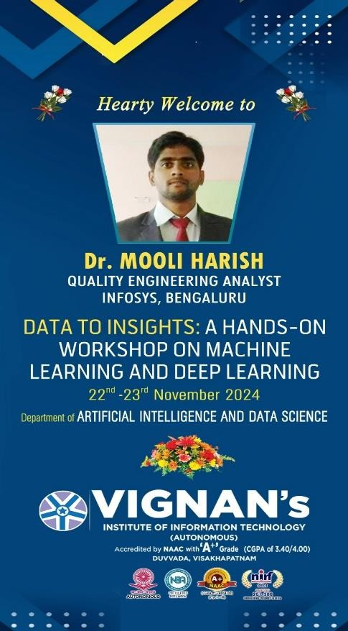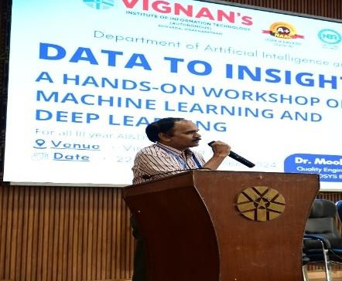

DEEP LEARNING

by Dr.Mooli Harish, Quality Engineering Analyst Infosys, Bengaluru. Organised by Vignan's Institute of Information Technology(A),On 23.11.2024

# Co-Curricular Activities:

|  |  |  |
| --- | --- | --- |
| S.No. | Date | Name of the event |
| 1 | 02.11.2024 | A Industrial Visit by AMTZ Organised by The department of Electrical and Electronics Engineering, VIIT(A), |
| 2 | 06.11.2024 | Awareness Programme on Cyber Crime by Sri Shanka Brata Bagchi, IPS, Commissioner of Police, Visakhapatnam |
| 3 | 08.11.2024 | Industrial Visit to Défense Research and Development Organization (DRDO) and SITAR industry, Bangalore by defence Research and Development Organization (DRDO) and SITAR industry, Bangalore. |
| 4 | 11.11.2024 | Awareness Program on Intellectual Property Rights & Patents by Mr.M.Srinivas, Eva IT and IP services by Mr.M.Srinivas, Eva IT and IP services, Organised by The Entrepreneurship Development Cell,VIIT(A). |
| 5 | 13.11.2024 | An awareness Program on Entrepreneurship by Mr.V.Adiseshu, Joint Director,DIC Vizag by Mr.V.Adiseshu, Joint Director, DIC Vizag Organised by The Entrepreneurship Development Cell, VIIT(A). |
| 6 | 15.11.2024 | Industrial Visit to AMTZ, Visakhapatnam by AMTZ Organised by The Department of Management Studies, VIIT(A). |
| 7 | 20.11.2024 | An awareness session on Integrating Science and spirituality at 21st century by Shri.Arun Agarwal, Shri. K.Vasudevarao, Alumnus,IIT Kanpur, Bakthiveda Institute |
| 8 | 25.11.2024 | Industrial VISIT to RINL-VIZAG STEEL PLANT by Kalpataru RINL Steel Plant Organised by Vignan's Institute of Information Technology(A). |
| 9 | 26.11.2024 | CONSTITUTION DAY OF INDIA - POSTER MAKING COMPETITION - Organised by Vignan's  Institute of Information Technology |
| 10 | 30.11.2024 | An Alumni Guest Lecture - Corporate Expectations : MBA Graduates by Mr. KVS Rajesh, Asst.Manager Ernst& Young LLP by Mr. KVS Rajesh, Asst.Manager Ernst& Young LLP Organised by The Department of Management Studies, VIIT(A). |

1. **Co-Curricular Activities:**

|  |  |  |
| --- | --- | --- |
| S.No | Particulars | Image |
| 1. | **A Industrial Visit by AMTZ Organised by The department of Electrical and Electronics Engineering, VIIT(A),On 02.11.2024;**  About event:  Total 54 students of 3rd EEE Visited the Convention Center and Artificial Limb Center to see the manufacturing and demo of various prosthetics and orthotics devices. Adapted various assistive technology devices Also visited the advance medical technology lab to see the various electrical and mechanical engineering manufacturing devices and operation and control Various medical devices and life supporting devices. |  |

|  |  |  |  |  |
| --- | --- | --- | --- | --- |
|  | 2. | **Awareness Programme on Cyber Crime**  by Sri Shanka Brata Bagchi, IPS, Commissioner of Police, Visakhapatnam and Mr. O. Naresh, Symbiosis CEO by Sri Shanka Brata Bagchi, IPS, Commissioner of Police, Visakhapatnam and Mr. O. Naresh, Symbiosis CEO Organised by Vignan's Institute of Information Technology(A),On 06.11.2024 |  |  |
| 3. | **Industrial Visit to Défense Research and Development Organization (DRDO) and SITAR industry,**  **Bangalore**  by Défense Research and Development Organization (DRDO) and SITAR industry, Bangalore by defence Research and Development Organization (DRDO) and SITAR industry, Bangalore Organised by The department of Electronics and Communication Engineering,  VIIT(A),On 08.11.2024 |  |
|  | | | | |

|  |  |  |  |  |
| --- | --- | --- | --- | --- |
|  | 4. | **Awareness Program on Intellectual Property Rights & Patents by** Mr.M.Srinivas, Eva IT and IP services by Mr.M.Srinivas, Eva IT and IP services Organised by The Entrepreneurship Development Cell,VIIT(A),On 11.11.2024 | WhatsApp Image 2024-11-12 at 13.52.23.jpeg  WhatsApp Image 2024-11-12 at 13.52.22.jpeg SRK_8980.JPG |  |
|  | | | | |

|  |  |  |  |  |
| --- | --- | --- | --- | --- |
|  | 5. | **An awareness Program on Entrepreneurship by Mr.V.Adiseshu, Joint Director,DIC Vizag**  by Mr.V.Adiseshu, Joint Director, DIC Vizag Organised by The Entrepreneurship Development Cell, **VIIT(A),On 13.11.2024** |  |  |
| 6. | **Industrial Visit to AMTZ, Visakhapatnam** by AMTZ Organised by The Department of Management Studies, VIIT(A),On 15.11.2024 | WhatsApp Image 2024-11-14 at 15.31.06.jpeg |
|  | | | | |

|  |  |  |  |  |
| --- | --- | --- | --- | --- |
|  | 7. | **An awareness session on**  **Integrating Science and spirituality at 21st century** by Shri.Arun Agarwal, Shri. K.Vasudevarao, Alumnus, IT Kanpur, Bakthiveda Institute by Shri.Arun Agarwal, Shri.  K.Vasudevarao, Alumnus,IIT Kanpur, Bakthiveda Institute Organised by Vignan's Institute of Information Technology(A),On 20.11.2024 |  |  |
| 8. | **Industrial VISIT to RINL-VIZAG STEEL PLANT by Kalpataru RINL Steel Plant Organised by Vignan's Institute of Information Technology(A),On 25.11.2024**  Event:VIIT's ED Cell organized an industrial visit to Kalpataru RINL Steel Plant for 40 B.Tech students of 3rd Year. Students learned about Industry 4.0, startup opportunities, and the Kalpataru COE's Rolling Model for student startups. The visit aimed to encourage students towards innovation and entrepreneurship. |  |
|  | | | | |

|  |  |  |  |  |
| --- | --- | --- | --- | --- |
|  | 9.  10 | **CONSTITUTION DAY OF INDIA - POSTER MAKING COMPETITION**  **Organised** by Vignan's Institute of Information Technology, On 26.11.2024  **An Alumni Guest Lecture - Corporate Expectations: MBA**  **Graduates** by Mr. KVS Rajesh, Asst.Manager Ernst& Young LLP by Mr. KVS Rajesh, Asst.Manager Ernst& Young LLP Organised by The Department of Management Studies, VIIT(A),On 30.11.2024 |  |  |
|  | | | | |

# Research Activities

|  |  |  |
| --- | --- | --- |
| S.No. | Date | Name of the event |
| 1 | 20.11.2024 | FDP on “Potential Research Areas and Effective Research Paper Writing” by Dr.K.Prabhakara Rao, Prof.-Head. Dept. of Chemistry, Vignan University - Guntur by Dr.K.Prabhakara Rao, Prof.-Head. Dept. of Chemistry, Vignan University - Guntur Organised by The department of Basic Sciences and Humanities, VIIT(A). |
| 2 | 21.11.2024 | A Workshop on Research Paper Writing by Dr.Nirupam Bhat Mundukur, Professor, Dr.Jyostna Devi Bodapati,Associate Professor , Dept. of ACSE, Vignan University-Guntur by Dr.Nirupam Bhat Mundukur, Professor, Dr.Jyostna Devi Bodapati,Associate Professor , Dept. of ACSE, Vignan University-Guntur Organised by The department of Computer Science Engineering, VIIT(A). |
| 3 | 30.11.2024 | A Seminar on Potential research areas and effective research paper writing by Dr.M.Laavanya , Associate Dean IQAC, VFSTR by Dr.M.Laavanya , Associate Dean IQAC, VFSTR Organised by The department of Computer Science Engineering, VIIT(A). |

1. **Research Activities**

|  |  |  |
| --- | --- | --- |
| S.No | Particulars | Image |
| 1. | FDP on “Potential Research Areas and Effective Research Paper Writing” by Dr.K.Prabhakara Rao, Prof.-Head. Dept. of Chemistry, Vignan University - Guntur by Dr.K.Prabhakara Rao, Prof.-Head. Dept. of Chemistry, Vignan University - Guntur Organised by The department of Basic Sciences and Humanities, VIIT(A),On 20.11.2024 |  |

|  |  |  |  |  |
| --- | --- | --- | --- | --- |
|  | 2. | A Workshop on Research Paper  Writing by Dr.Nirupam Bhat Mundukur, Professor, Dr.Jyostna Devi Bodapati,Associate Professor , Dept. of ACSE, Vignan University- Guntur by Dr.Nirupam Bhat Mundukur, Professor, Dr.Jyostna Devi Bodapati,Associate Professor , Dept. of ACSE, Vignan University- Guntur Organised by The department of Computer Science Engineering, VIIT(A),On 21.11.2024 |  |  |
| 3. | **A Seminar on Potential research areas and effective research paper writing** by Dr.M.Laavanya , Associate Dean IQAC, VFSTR by Dr.M.Laavanya , Associate Dean IQAC, VFSTR Organised by The department of Computer Science Engineering, VIIT(A),On 30.11.2024 | WhatsApp Image 2024-12-02 at 10.45.36.jpeg |
|  | | | | |

# Student Support Practices

|  |  |  |
| --- | --- | --- |
| S.No. | Date | Name of the event |
| 1 | 05.11.2024 | An awareness Program on Cancer Prevention for I-B.Tech Students by Dr. Anitha Raj, M.A., MBA, Ph.D Preventive Oncology from “The Indian Cancer Society”. by Dr. Anitha Raj, M.A., MBA, Ph.D  Preventive Oncology from “The Indian Cancer Society”. Organised by The department of Basic Sciences and Humanities, VIIT(A). |
| 2 | 06.11.2024 | The Status of broadcasting the Autobiography of the Eminent Personality - Broadcasted the Autobiography of Shri Ratan Tata by Organised by Vignan's Institute of Information Technology(A). |
| 3 | 14.11.2024 | YUVA -Vignan Students Performed a Skit at CMR Central - Visakhapatnam by Organised by Vignan's Institute of Information Technology(A). |
| 4 | 18.11.2024 | Awareness program on U.S VISA Application Process by U.S. Consulate General, Hyderabad |
| 5 | 19.11.2024 | Awareness program on U.S VISA Application Process by U.S. Consulate General, Hyderabad |

1. **Student Support Practices**

|  |  |  |
| --- | --- | --- |
| S.No | Particulars | Image |
| 1. | An awareness Program on Cancer Prevention for I-B.Tech Students by Dr. Anitha Raj, M.A., MBA, Ph.D  Preventive Oncology from “The Indian Cancer Society”. by Dr. Anitha Raj, M.A., MBA, Ph.D Preventive Oncology from “The Indian Cancer Society”. Organised by The department of Basic Sciences and Humanities, VIIT(A),On 05.11.2024  Event:  The Basic Sciences and Humanities (BSH) Department at Vignan’s Institute conducted an enlightening ‘’Awareness Program on Cancer Prevention’’ for first-year B. Tech students. Dr. D. Raga Sudha, an esteemed faculty member from the BSH Department, organized and led the session, aimed at educating students on cancer prevention and the importance of early detection. |  |
| 2. | The Status of broadcasting the Autobiography of the Eminent Personality - Broadcasted the Autobiography of Shri Ratan Tata by Organised by Vignan's Institute of Information Technology(A),On 06.11.2024 |  |

|  |  |  |  |  |
| --- | --- | --- | --- | --- |
|  | 3. | YUVA -Vignan Students Performed a Skit at CMR Central - Visakhapatnam by Organised by Vignan's Institute of Information Technology(A),On 14.11.2024 |  |  |
| 4. | Awareness program on U.S VISA Application Process by U.S. Consulate General, Hyderabad   1. Jeanne. S - Deputy Consular Information Unit Chief 2. Aishwarya Rawat - Supervisor - Consular Information Unit by U.S. Consulate General, Hyderabad 3. Jeanne. S - Deputy Consular Information Unit Chief 4. Aishwarya Rawat - Supervisor - Consular Information Unit Organised by Vignan's Institute of Information Technology(A),On 18.11.2024 |  |
|  | | | | |

|  |  |  |  |  |
| --- | --- | --- | --- | --- |
|  | 5. | Awareness program on U.S VISA Application Process by U.S. Consulate General, Hyderabad-  1. Jeanne. S - Deputy Consular Information Unit Chief ,2. Aishwarya Rawat - Supervisor - Consular Information Unit and Alexzander- public officer by  U.S. Consulate General, Hyderabad- 1. Jeanne. S  - Deputy Consular Information Unit Chief ,2. Aishwarya Rawat - Supervisor - Consular Information Unit and Alexzander- public officer Organised by Vignan's Institute of Information Technology(A), **On 19.11.2024** |  |  |
|  | | | | |

1. **Creative & Innovative in curriculum**.

|  |  |  |
| --- | --- | --- |
| S.No. | Date | Name of the event |
| 1 | 18.11.2024 | Add-On Course on BHAGAVAD GITA, in collaboration with ISKAN, Visakhapatnam by Organised by The Department of Civil Engineering, VIIT(A). |

|  |  |  |
| --- | --- | --- |
| S.No | Particulars | Image |
| 1. | Add-On Course on BHAGAVAD GITA, in colloboration with ISKAN, Visakhaptnam by Organised by The Deaprtment of Civil Engineering, VIIT(A),On 18.11.2024  Event:  One week Addon course on Bhagavad Gita started today for II B.Tech Civil and ECM students |  |